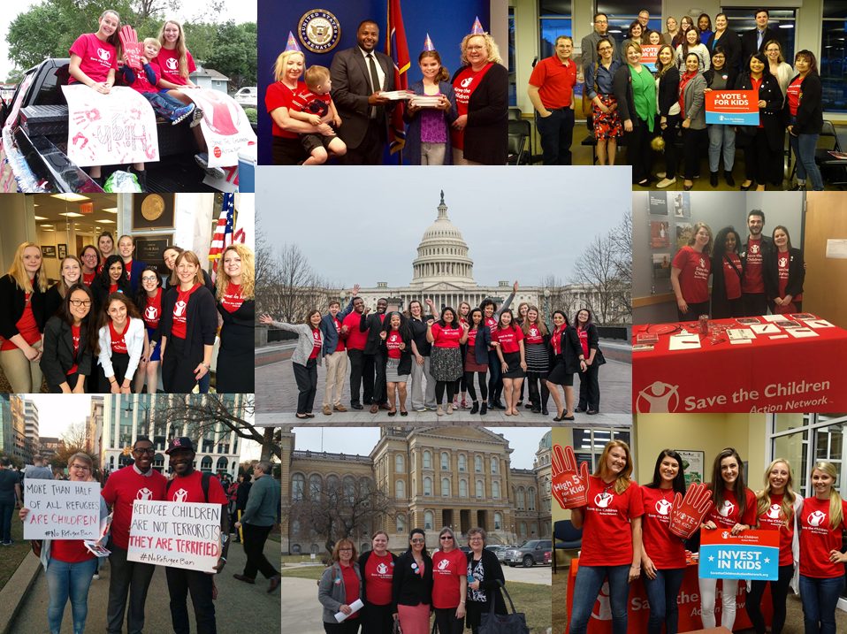

Save the Children Action Network
2017 Advocacy 101 Toolkit

Save the Children Action Network’s 2017 Advocacy 101 Toolkit
Table of Contents

- Background
  - About Save the Children…………………………............................……………….Pages 4-5
  - About Save the Children Action Network…………………………......…………..Page 6
  - Early Childhood Education…..………………..……………………….………….….Page 7
  - Maternal, Newborn and Child Survival……………………..………....………..….Page 8
  - What Influences Elected Officials ?.......................................................………….....Pages 9-10
- Tactics
  - Letters and Phone Calls……………………………………...….......…..….…....Pages 11-12
  - Letters to the Editor………………………..………...............................…..…….....Page 13-14
  - Social Media……………………………...…………………...…….…………......Pages 15-16
  - Engaging Elected Officials at Home…...………...…….........................………...Page 17-18
- Additional Resources……………………………………………………………….....……...Page 19

Introduction
We created this toolkit to provide you with the information and resources you need to be an effective advocate on behalf of children in need. Kids can’t vote and they don’t give money to political candidates, so they need all of us to make sure their issues are addressed by our local, state and federal elected officials.
Each time you use your voice with Save the Children Action Network (SCAN) by making calls, writing letters, attending local events or sharing messages on social media, you are helping to elevate two of the most pressing issues facing children—the lack of high-quality early childhood education in the U.S. and the preventable deaths of mothers and children around the world.
SCAN believes that all kids deserve a strong start to life, no matter where they are born, and we can only achieve that vision with the help and support of dedicated volunteers like you! Together, we can be the political voice for kids.
Thank you for joining us in this important effort!

“Humanity owes the child the best we have to give.”
- Eglantyne Jebb, Founder of Save the Children

About Save the Children
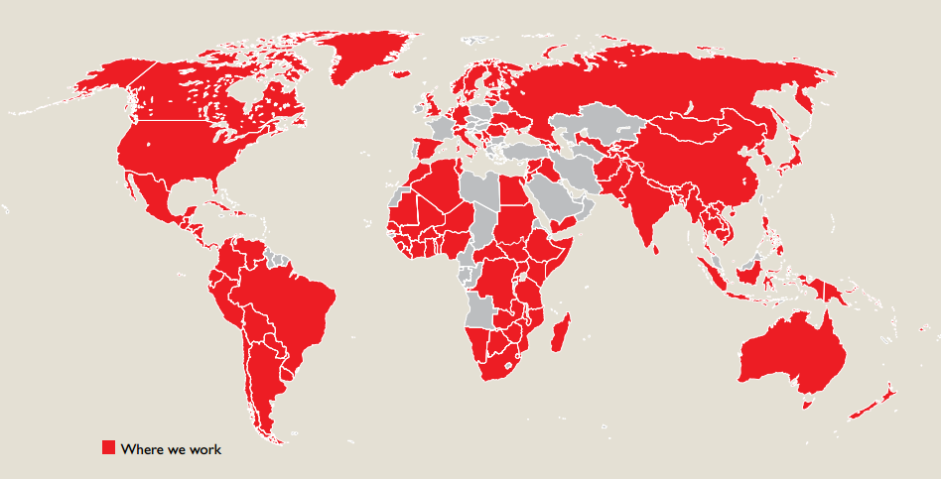
Save the Children is the nation’s preeminent child-serving organization investing in childhood in the U.S. and around the world. Save the Children is a nonpartisan organization that is respected by Americans of all political persuasions for its work to give children a healthy start, the opportunity to learn and protection from harm. Save the Children believes that by transforming children’s lives now, we can change the course of their future and ours. In 2016, Save the Children worked in 120 countries and helped more than 157 million children.
Every Day
Save the Children works in communities in the United States and around the world, making sure children are healthy, nourished, protected and learning. Through our groundbreaking work in child survival, early education and child protection, we provide children with a strong foundation for the future.

In Times of Crisis
When children are at their most vulnerable—when disaster strikes, in times of tragedy, when their caregivers are overwhelmed and under-resourced—Save the Children is there. We ensure children’s unique needs are addressed and their childhoods can continue.

For Our Future
Save the Children works to ensure that our decades of practical experience translate into lasting change for generations of children to come. We work with policymakers at the local and global levels, advocating for policies that will give millions of children the best chance for success—securing a better future for us all.
For more information please visit www.SavetheChildren.org.
About Save the Children’s U.S. Programs
In the United States, Save the Children specializes in delivering programs centered on early education, literacy and health in rural communities. In 2016, we directly served 317,000 children across 16 states.
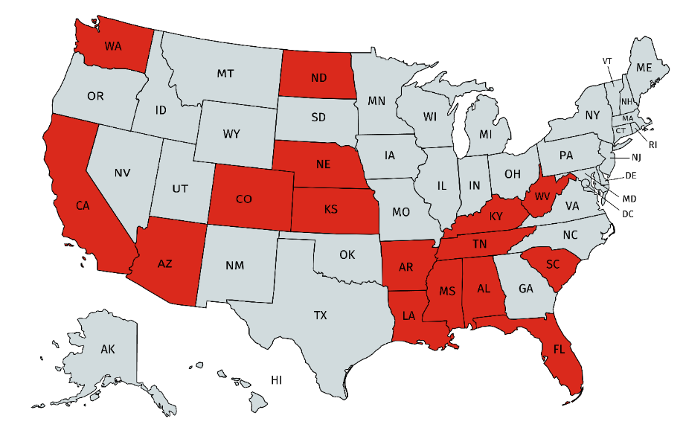

Save the Children reaches children ages zero to five through two paths: the management of Head Start programs and our own signature Early Steps to School Success program.

Head Start
Save the Children operates six Head Start and Early Head Start programs in 18 counties across Arkansas, Louisiana, Mississippi and North Dakota, serving 2,600 children. Head Start and Early Head Start are federally funded early childhood development programs aimed at promoting school readiness and social and emotional development for children from low-income families.

Early Steps to School Success
Save the Children introduced its Early Steps to School Success program in 2006. Built on public-private partnerships with local schools and states, Early Steps delivers high-quality early childhood development services to children ages zero to five and their families in 14 states. This signature program is a low-cost, targeted approach to enhancing school readiness for children in some of America’s most under-resourced communities.

About Save the Children Action Network
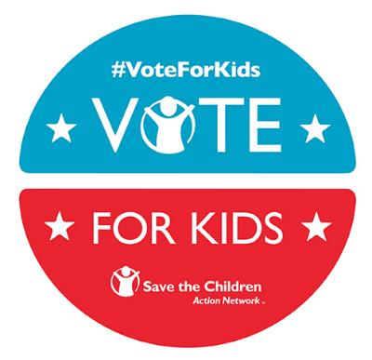
Save the Children Action Network (SCAN) is the political advocacy arm of Save the Children, founded in 2014 to give children a stronger voice in the U.S. political system.

SCAN rewards politicians who champion children’s issues and holds others accountable when they vote against kids. We act as the “Voice for Kids” by bringing their issues directly to lawmakers in Washington, D.C. and in state capitals and local communities across the country.

Our strategy includes a combination of grassroots mobilization, press and social media outreach, government relations, and political action, focused on two objectives critical to early childhood success:

- Ensuring access to high-quality early education for every child in the U.S.

- Ending preventable maternal, newborn and child deaths around the world.

In order to achieve these goals on behalf of kids, we are building a movement of passionate and committed volunteers, like you, who are willing to take action at key moments. In 2016, our base of supporters wrote, called and signed their names to more than half a million messages to local, state and federal lawmakers in support of investments in kids.

On the national level, SCAN is activating a network of student and adult volunteers from all 50 states to participate in key federal campaigns focused on early childhood education and maternal, newborn and child survival. At the state level, we have an on-the-ground presence in six target states—Iowa, Illinois, New Hampshire, South Carolina, Tennessee and Washington—where we focus on local and state policy related to early childhood education, in addition to our national campaigns.

For more information you can go to: SavetheChildrenActionNetwork.org.

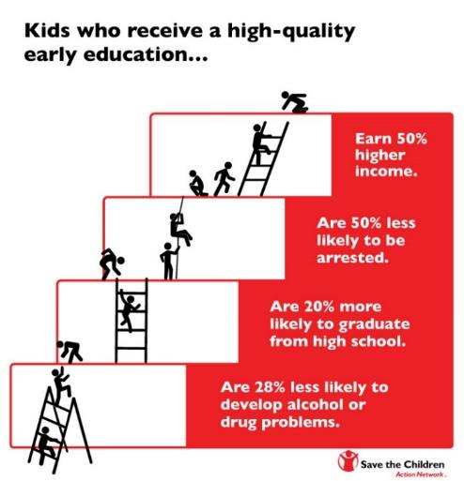
Our Domestic Issue: Early Childhood Education
All Kids Deserve A Strong Start.
Investing in early childhood education is the most effective way to break the cycle of poverty. These investments lay the foundation for success later in school, career and life. The type of environment and the quality of interaction to which children are exposed in the first five years of life greatly influence the outcomes of their adult lives.

The Problem.
By age 5, a child’s brain is nearly completely developed, yet 2 out of 5 American children are not enrolled in preschool. Without access to high-quality early learning programs, children fall behind. Many never catch up.

The Solution.
Programs that start at birth and carry a child to kindergarten are the best investment for a strong future. High-quality early childhood education is an investment this country needs to make in order to give all kids a fair start in life.

In addition to being a smart investment, early childhood education has strong bipartisan support—a 2015 battleground poll, paid for by SCAN, found that 51 percent of committed Republican voters and 92 percent of committed Democratic voters support an increase in funding for early learning programs.

The Strategy.
In 2016, SCAN convened an “Action Tank” on early learning, bringing together senior leaders from the corporate sector, think tanks and non-profits, in order to develop specific recommendations on how to expand access to quality early childhood education programs through comprehensive tax reform. We are sharing these recommendations with the Trump administration and Congress in order to build consensus on funding opportunities for early leaning.

In addition to our work on tax reform, we advocate for preserving and increasing current federal spending around early learning. Key programs include:
- The Child Care and Development Block Grant program, which helps low-income families pay for child care.
- Head Start and Early Head Start, which provide comprehensive early care and education to our poorest children. Services include a mix of classroom programs, home visiting and comprehensive family services.
- The Preschool Development Grant program, which encourages states to establish, expand or improve the quality of their own prekindergarten programs.
Our Global Issue: Maternal, Newborn and Child Survival
The Problem.
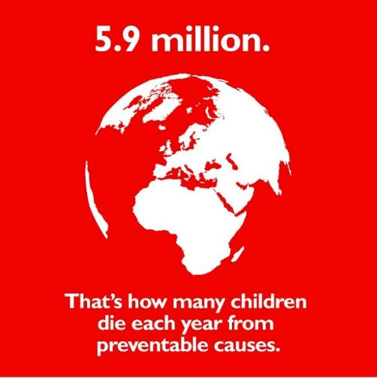
Globally, 16,000 children under age five die every day from preventable or treatable causes, such as diarrhea and pneumonia. Additionally, 800 women die each day due to complications during pregnancy or childbirth.

The Solution.
The United States has been a leading voice for reducing maternal, newborn and child mortality rates for decades. Through investments in proven and cost-effective interventions, we have helped save the lives of more than 4.6 million children and 200,000 women over the past 8 years.

The Strategy.
In 2015, SCAN worked with a coalition of more than 30 diverse non-profit organizations to help draft and introduce the Reach Every Mother and Child Act in the U.S. Congress. This bipartisan piece of legislation would help U.S. programs reach more moms and kids with proven and inexpensive health solutions that are critical to their survival. If enacted, it would put the world on a path to end preventable deaths of moms and kids within a generation. While this legislation did not pass in 2016, it received the largest bipartisan support of any international development effort in recent years—219 members of the House of Representatives and 36 Senators cosponsored the bill. In 2017, SCAN will push for the Reach Act to be reintroduced and passed by the 115th Congress.

In addition to passing the Reach Act, it is critical that Congress continues to fund key global health and nutrition accounts. The Trump Administration has proposed significant cuts to these programs, which represent less than 1 percent of the total federal budget, but are critical to the survival of moms and kids around the world. SCAN advocates to preserving and increasing these federal investments so that no mother or child dies an unnecessary death.
“At our best, being a great nation has always meant a commitment to building a better, safer world—not just for ourselves, but for our children and grandchildren. This has meant leading the world in advancing the cause of peace, responding when disease and disaster strike, lifting millions out of poverty and inspiring those yearning for freedom.”
- Colin L. Powell, Former Secretary of State

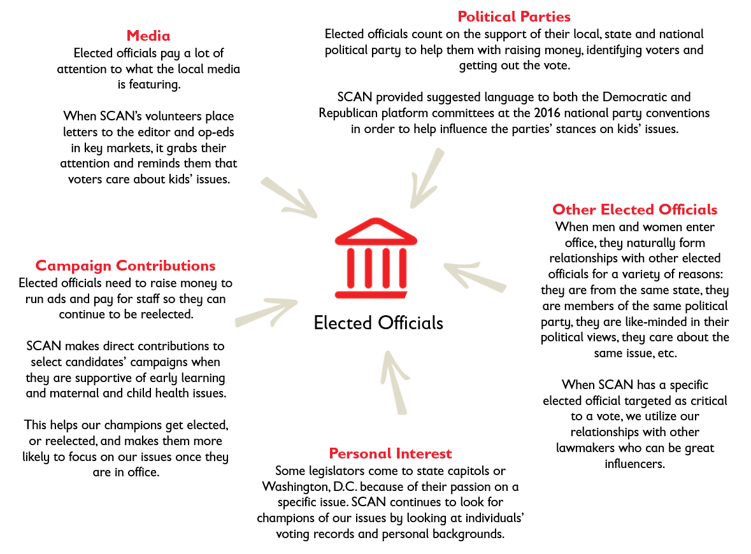
What Influences Elected Officials?
Given that lawmakers are always thinking of their next election, they care deeply about what their constituents think. The more SCAN advocates come together, with the same messages, at the same time, asking for the same action, the more elected officials will take notice. This is where SCAN volunteers can really make a difference on behalf of children.

It is also important for SCAN volunteers to understand the other ways elected officials are influenced so that we can understand what motivates their actions.

Congressional Management Foundation Survey
The chart below comes from an online survey of congressional staff on their opinions and practices related to constituent communications, including grassroots advocacy campaigns and social media. While some contacts are more impactful than others, the best campaigns incorporate multiple contact methods so to demonstrate the depth and breadth of support an issue has.
Effective Ways to Influence Elected Officials:
Hand Delivered Letters and Phone Calls

As the earlier survey indicates, individualized phone calls and letters are two of the more impactful ways to influence legislators. Writing a letter or calling your elected official is one of the most powerful and effective ways you can use your voice to raise awareness about the needs of vulnerable children and put positive pressure on elected leaders to act.

Calling or writing a letter is easy to do and only takes a few minutes. Every letter and call is tallied by the office so it only takes a few calls and letters to get the attention of your elected leaders!

To start, look up the address and phone number of your elected official at
www.usa.gov/elected-officials.

Writing a Letter to Your Elected Official:

- Start with your “ask.” What it is that you want your elected official to do? If you want them to support specific legislation, make sure to include the bill number.

- Keep it simple and short. Letters should be kept to one page. You should also keep your letter to just one “ask” so they know exactly what you would like them to do.

- Make it personal by including a sentence or two about why you care about the particular issue and/or how it affects your community.

- Always include your address so their office knows you are a constituent and knows where to send a response.

- Ask your friends, family and colleagues to write letters too! Personalized letters make the greatest impact when they are delivered in person to the elected official’s office. The more letters you can deliver at once, the stronger the message!

- If you are sending your letter directly to your elected official, consider writing a post card. Security at many state capitals and congressional offices causes delays for letters sent in envelopes. Post cards will arrive more quickly if your message is urgent!

Calling Your Elected Official:
- If you are calling your representative or senator, they will not be the one to take your call so you don’t have to be nervous! A staffer will answer the call and take down your message to tally with other constituent calls they receive that day. Remember that as a constituent they work for you!

- If you are calling your state representative or local official, they may answer your call personally. They will be happy to hear from their constituent, so don’t be nervous. Remember, they represent you!

- You do not have to be an expert. Do not feel that you have to memorize facts and figures before your call. It’s more important to express that you are a constituent who is passionate about helping kids. Typically, they will not question you on policy issues. If they do ask something you aren’t sure about, tell them you don’t know but will find out and follow up with them. Then be sure to reach out to your SCAN contact to find out the answer.

- When you call, tell the person who answers that you are a constituent and give them your address so that they can mail you a written response.

- Be brief. The person who answers the phone receives many calls every day. Simply let them know why you are calling and that you are a constituent. Be sure to give them the bill number if you are calling about a specific piece of legislation.

- Ask others to join you in making calls!

Letters to the Editor

Writing a letter to the editor (LTE) of your local or regional newspaper is a great way to get the attention of your elected official, as well as reach a large audience in your community. LTE’s are printed on the editorial page, which is one of the most read pages in the paper. Elected officials’ staff monitor their local newspapers every day to track the mood and views of voters – that’s why LTE’s are a great way for your elected official to hear your voice. SCAN staff also share the LTE’s with congressional offices, if they are printed.
Here are a few tips for writing and submitting your letter to the editor:
- LTE’s should be about 150-200 words long. Each newspaper has different requirements, so make sure to check the paper’s website before you submit your letter.

- Think about including a personal story that tells why you’re passionate about the issue. Maybe you’re preparing for the back to school season, for example, and want to write about the opportunities you’ve had to receive a quality education. Or maybe you have experienced having a sick child and you don’t want any mother to have to watch their child suffer. If you can think about a personal experience to write about, it will help readers connect to your LTE.

- Make an “ask.” Ask your elected official to take a specific action in the areas of early childhood education or maternal, newborn and child survival. The SCAN staff will help you with talking points if you need assistance. Write in a way that encourages the elected official and readers to take action!

- Many newspapers will have a submission form on their websites. To find that, go to the Opinion section on your local newspaper’s website and look for “Submit a Letter to the Editor.” You can also email it to the paper’s Opinions editor.

- Remember: If you need help with writing and/or submitting a letter to the editor, reach out to the SCAN staff member that you’re in contact with. We are happy to help! Don’t forget to let us know if you submit a LTE to your local paper.

Sample Letter to the Editor

Posted: 5/4/2017
Author: Andrea van der Hoek, Palatine, Illinois
As a pediatric emergency nurse, I regularly care for children and families. I see daily the positive impact of access to basic health care. Things as simple as antibiotics, vaccines, nutrition, and hydration save lives. Unfortunately, this access is not easily available to all children. As a mother myself, I cannot imagine being unable to obtain such basic care for my daughter.
The United States has been a global leader in helping to save the lives of children from illnesses such as pneumonia, malaria and diarrhea. Since 1990, American international aid has helped reduce preventable deaths of children worldwide by more than half. There is more work to do, but that is an incredible accomplishment that has helped stabilize our world.
But now, programs that have helped save millions of lives are in jeopardy. President Trump proposed devastating cuts to the foreign assistance budget. Drastic cuts to successful programs would reverse all that America has done to build stronger communities and save lives around the world.
As an advocate for Save the Children Action Network, I know that we should preserve America's legacy of helping children around the world survive and thrive. I urge Sen. Durbin to protect funding for critical health and nutrition programs that save moms and kids as they consider Fiscal Year 2017 and 2018 appropriations. Investing in kids today helps create a better tomorrow.

Social Media
How to Ask Lawmakers to #InvestInKids via Social Media
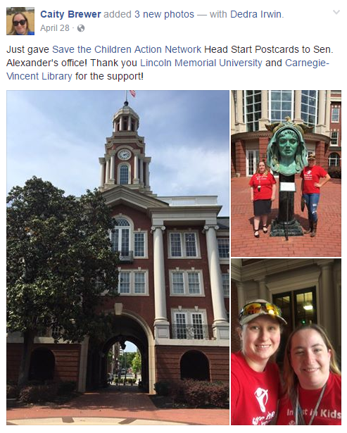
In addition to writing a letter or calling your elected officials, or sending a letter to the editor, social media is an effective way to let your voice be heard. While elected officials and their staff DO track engagement form social media sites, you may not receive a direct response. But don’t let that deter you! Social posts are quick and easy to do – and, most importantly, they are public, so more people will see your message.

Top Tips:

- Use hashtags. If you know of an existing hashtag that corresponds with a bill/issue (e.g. #SaveMomsandKids, #earlyed), use it—more people will see your message. You can find hashtags by searching social sites or from an organization’s website where you often can find information about social media engagement. In some cases, if there is not a relevant bill hashtag, it may make sense to use the formal bill name or co-sponsor handles. You can also use #InvestinKids. This will help SCAN see your posts!

- Write in a personal voice and share why you’re passionate about the issue. Personal stories can make a big impact!

- Post to your social sites to engage your friends, family and coworkers. The more people your lawmakers hear from, the better chance you have of seeing them take action!
  - Send messages urging others to contact their lawmakers.
  - Post links to petitions, information on contacting a specific lawmaker and examples of why you’re using your voice to urge legislators to act on a matter impacting children.

- Tag SCAN in your posts. We want to see the great work you’re doing in your community. Simply include our handle (@SCActionNetwork) in your tweet or tag us on Facebook (@SavetheChildrenActionNetwork).

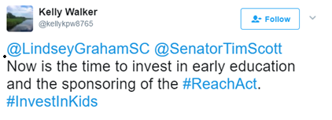
- Include a period in front of their handle when starting a tweet with the elected official’s name. This will ensure your followers see the tweet. For example: “.@senchuckgrassley, Please protect funding for Head Start! #InvestInKids.”

- Take pictures! Posts with images get more engagement on social media and will show your followers the exciting things you’re doing with SCAN.

Find Your Elected Officials Online
Most elected officials have official Facebook and Twitter accounts, and many use other social sites like Instagram. The following resources can help you locate their official government accounts which you will want to use when contacting them via social media.

Look for this symbol next to the username.
- Google: The official website of the Member of Congress is the best resource for finding their official social accounts; you’ll often see the accounts clearly linked on their homepages.
- Find your representative here: http://www.house.gov/representatives/find/
- Find your senators here: http://www.senate.gov/general/contact_information/senators_cfm.cfm
- Public Twitter list of principal accounts of U.S. House members: https://twitter.com/gov/lists/us-house/members
- Public Twitter list of principal accounts of U.S. Senators: https://twitter.com/gov/lists/us-senate/members

And don’t forget to follow and like SCAN’s social media pages! We want to build an online community and feature your advocacy work happening across the country.
@SCActionNetwork
SavetheChildrenActionNetwork
@SavetheChildrenActionNetwork
SavetheChildrenActionNetwork
Engaging Elected Officials While They Are Back Home

Ask a Question at a Public Event
Sometimes during a campaign to get a bill passed or protect critical funding, it is very effective for a number of advocates to come together to approach an elected official at a key moment: it could be through a press conference, at a rally or even at a protest. SCAN staff will help you identify those opportunities and help you not only prepare for the event but identify others to involve as well.

A SCAN student advocate asked Senator Ted Cruz (R-TX) a question at the Iowa State Fair.

First, Find out where the official will be:
- Check their official website.
- Read your local paper.
- Join their email list. They often will tell you where they are going to be.
- It’s OK to show up again and again and ask similar questions.
Next, Show up and ask your question:
- Have your question ready and practice saying it out loud.
- SCAN staff can help you write a question.
- If they don’t answer your question, ask a follow-up.
Always remember to:
- Introduce yourself to the elected official and tell him/her you represent SCAN and are a voice for children.
- Arrive early to get a good seat.
- Be assertive (within reason!).
- If possible, take a picture (and post it on social media!).
- If you get to ask your question, make sure to let us know.

Request an “In-District” Meeting with Your Elected Representative
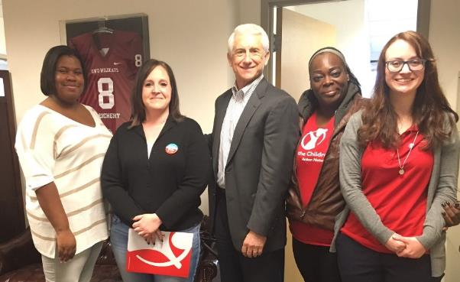
At key moments in the legislative process, especially when your member is home during a break from D.C. (typically called a “recess”), it may be a perfect time for you to sit down with him/her to talk about an issue. SCAN staff will help you identify those critical times and schedule an appointment.
Once you have a meeting scheduled, decide who will attend and what each person will say. Most meetings last no longer than 20 minutes, so it is important to have a plan in order to cover all of the important points.
SCAN advocates met with Congressman Dave Reichert (R-WA-8) in Washington State.
Follow these tips to be prepared:
- Wear your SCAN shirt to identify yourself as a volunteer! Contact the SCAN staff person in your state if you need shirts for yourself or others.

- Arrive ten minutes early to the meeting. If you don’t have a scheudled appotinment, you can try dropping by the office and leaving some SCAN materials with the front office staff.

- Introduce yourself, including your hometown and/or where you go to school. Indentify yourself as a SCAN advocate and mention why you are passionate about the issue you are there to disucss.

- Make your ask! Ask your elected official to take a specific action in the areas of early childhood education or maternal, newborn and child survival. The SCAN staff will help you with talking points if you need assistance. You can also use this opportunity to deliver post cards or petition signatures that you have collected!

- Thank the elected official or staffer for their time, and if possible, take a picture with the elected official to post on social media. If there is a book where the office logs consitutent meetings, make sure to sign your name and note that you were representing SCAN!

- Let us know how it went! Email your SCAN staff contact with a report back, including any questions you weren’t able to answer completely.

- Send a thank you note to the person you met with! This will help you build a long-term relationship with your contact at the office.

Additional Resources

Thank you for being a SCAN volunteer and tireless advocate for kids!
Your help is vital to ensuring that our elected leaders create real change for kids. Together, we can give every child a strong start in life.
We are here to help you every step of the way. Please keep us posted on your efforts and feel free to reach out with questions or ideas to your SCAN state staff.

More Resources
The Save the Children Action Network website has even more resources.
- Learn more about the issues. At SavetheChildrenActionNetwork.org/issues you can learn more about early childhood education and maternal and child survival.
- Learn more about our campaigns. At SavetheChildrenActionNetwork.org/campaigns you can learn about our current campaigns and participation in actions – online and off – to help kids.
- Read our blog. Our blog, called the Voice for Kids, has stories from volunteers like you, staff and coalition partners and more. Read inspiring and informative stories at SavetheChildrenActionNetwork.org/blog.

- Watch the training videos on our YouTube page: https://www.youtube.com/channel/UCDY3PjYGNLk82MRhQxx1E7g/videos

